Calculator Assumed
Linear and Quadratic Equations and Functions

Time: 45 minutes
Total Marks: 45
Your Score: / 45



Question One: [2, 2, 2 = 6 marks]
Consider the function .

- Which of these functions are parallel to ?
Circle or highlight all solutions.

- Which of these functions have the same vertical intercept as ?
Circle or highlight all solutions.

- Which of these functions have the same horizontal intercept as ?
Circle or highlight all solutions.

Question Two: [3, 1, 2, 2 = 9 marks]
The supply of S units of a particular product is given by where x is the number of days since production recommenced after a cease in production.
The demand for D units of this particular product is given by .
- Sketch each of these functions on the axes below.
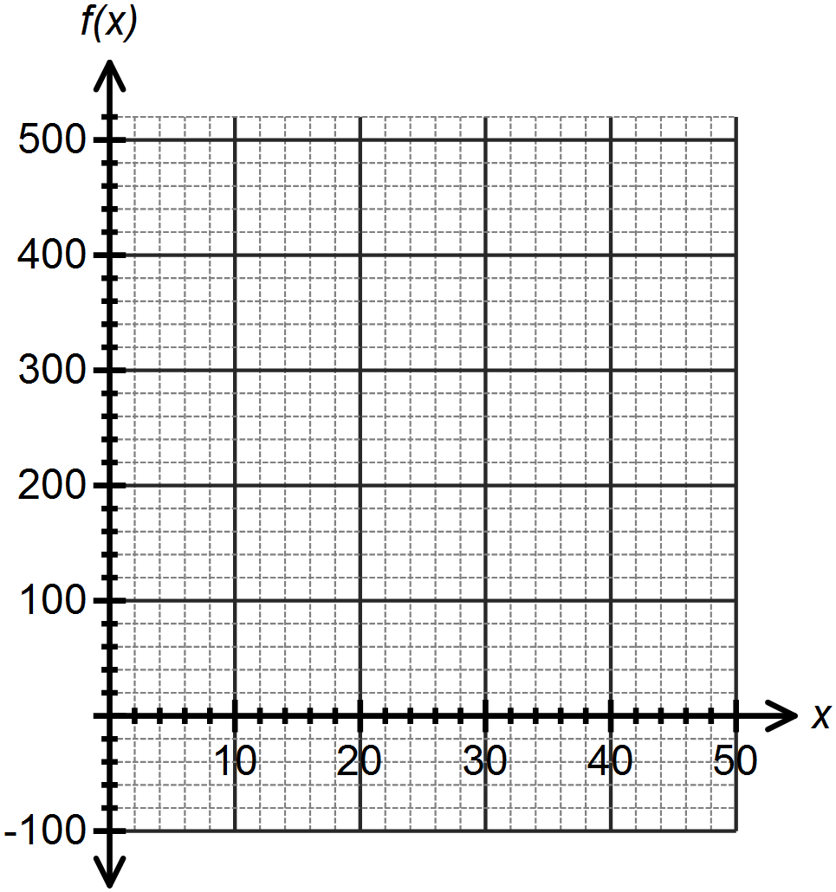

Use your graph to answer the following questions, correct to 2 decimal places:
- After how many days does demand meet supply the first time?

- For how many days does business “look good”, that is, demand is greater than supply?

- After how many days should the company look into a new advertising campaign? Justify your answer.

Question Three: [4, 3 = 7 marks]
- On the axes below sketch the function , showing all intercepts and turning points.
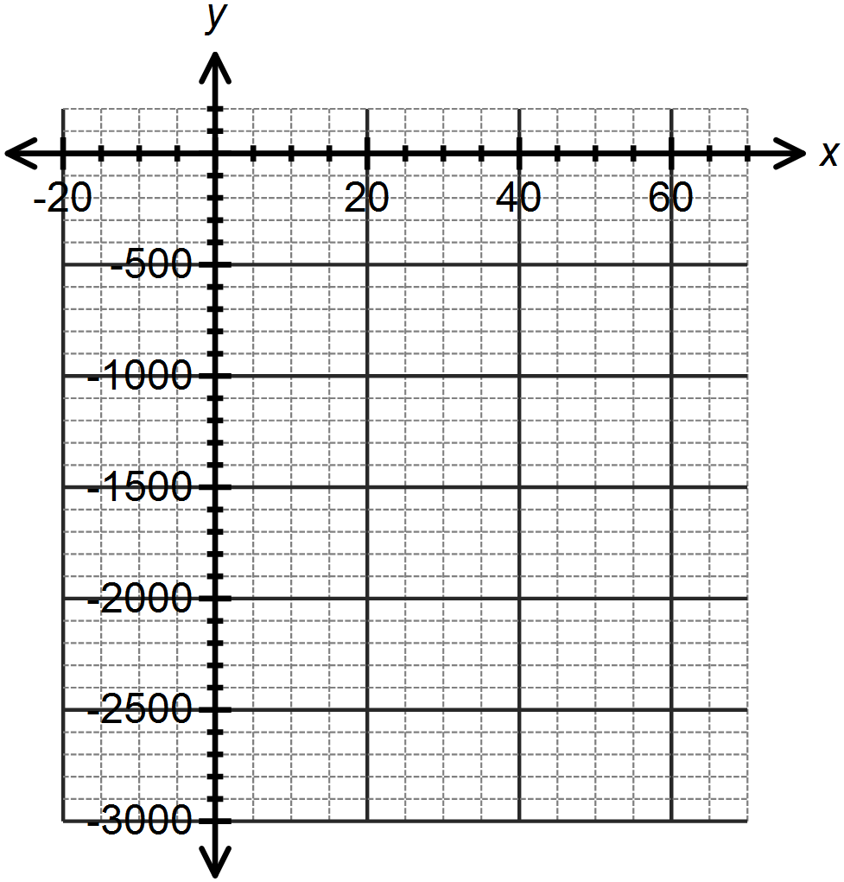

- Hence or otherwise transform the equation of the function into the form

Question Four: [3, 2 = 5 marks]
There are three children in a family. The eldest is twice the age of the youngest. The middle child is 3 years younger than the eldest. The sum of their ages is 47 years. Let x represent the age of the youngest child.
- Write an equation in one variable to represent this situation.

- Determine the age of each child.

Question Five: [3, 2 = 5 marks]
The area of a right triangle is .
The base is 3cm less than the height.
- Write an equation in one variable to represent this situation.

- Determine the dimensions of the triangle.

Question Six: [3, 1 = 4 marks]
- Explain, with reference to the discriminant in the quadratic formula, why the function has only one root.

- From your answer in part (a), what can you say about the turning point of this function?

Question Seven: [3, 3 = 6 marks]
Determine the equation of each of the functions drawn below.
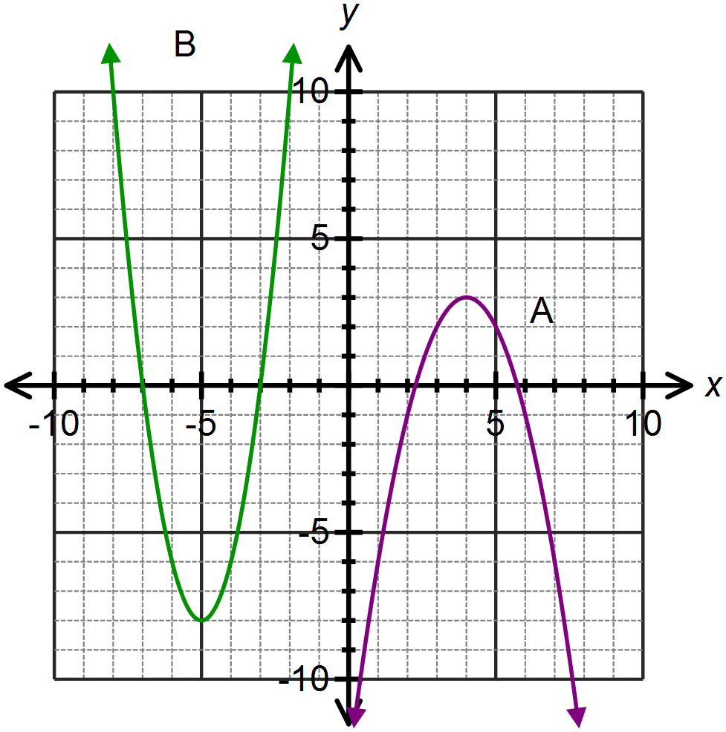

A:

B:

Question Eight: [3 marks]
Isabel throws a ball for her dog to catch. The path of the ball is parabolic and can be modeled by the equation where h is the height in metres of the ball above the ground and x is the horizontal distance of the ball from Isabel.
If Isabel’s dog is 4m away from her, how far does he have to jump to catch the ball?
Provide a sketch to illustrate your answer.

SOLUTIONS
Calculator Assumed
Linear and Quadratic Equations and Functions

Time: 45 minutes
Total Marks: 45
Your Score: / 45



Question One: [2, 2, 2 = 6 marks]
Consider the function .

- Which of these functions are parallel to ?
Circle or highlight all solutions.




- Which of these functions have the same vertical intercept as ?
Circle or highlight all solutions.




- Which of these functions have the same horizontal intercept as ?
Circle or highlight all solutions.



Question Two: [3, 1, 2, 2 = 9 marks]
The supply of S units of a particular product is given by where x is the number of days since production recommenced after a cease in production.
The demand for D units of this particular product is given by .

- Sketch each of these functions on the axes below.
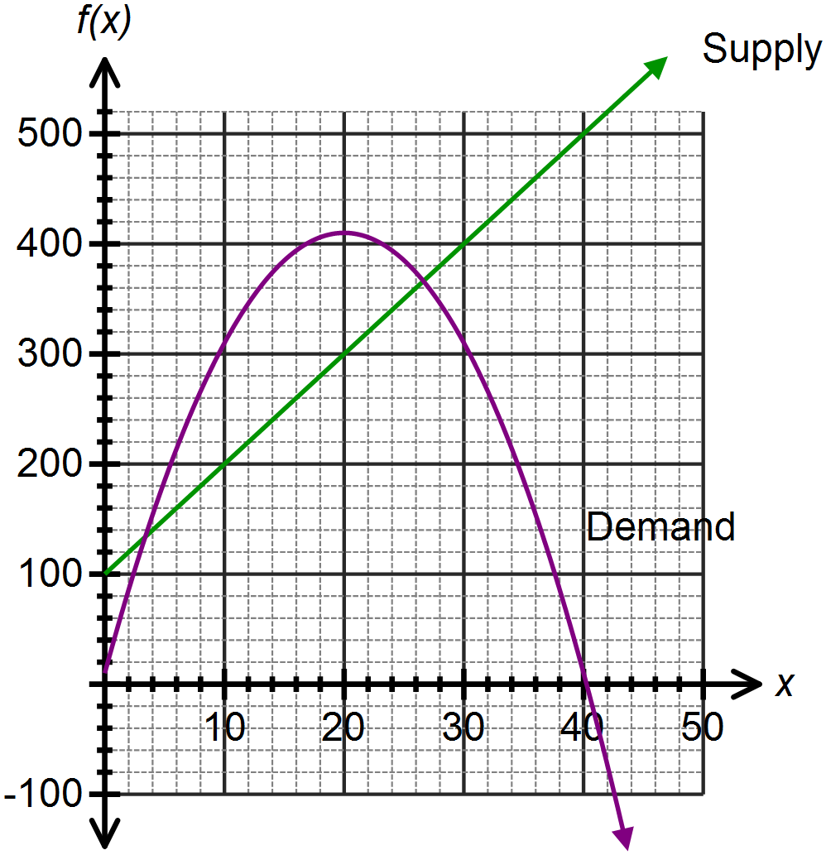




Use your graph to answer the following questions, correct to 2 decimal places:

- After how many days does demand meet supply the first time?
3.38 days



- For how many days does business “look good”, that is, demand is greater than supply?
26.62 – 3.38 = 23.24 $∴$ 23 days

- After how many days should the company look into a new advertising campaign? Justify your answer.


After 26.62 days. This is when demand starts to fall below supply.
Question Three: [4, 3 = 7 marks]
- On the axes below sketch the function , showing all intercepts and turning points.
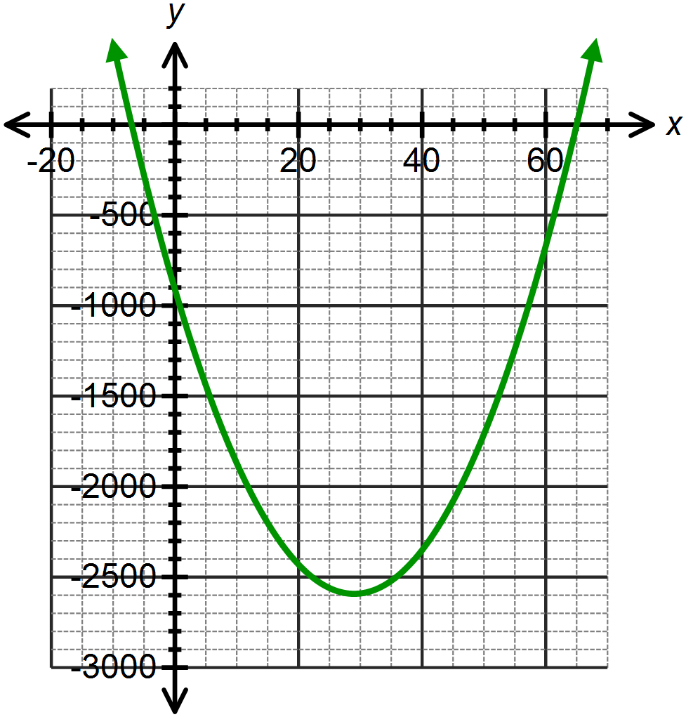







- Hence or otherwise transform the equation of the function into the form



Question Four: [3, 2 = 5 marks]
There are three children in a family. The eldest is twice the age of the youngest. The middle child is 3 years younger than the eldest. The sum of their ages is 47 years. Let x represent the age of the youngest child.


- Write an equation in one variable to represent this situation.


- Determine the age of each child.

Youngest is 10 years old

Middle child is 17 years old
Eldest child is 20 years old.
Question Five: [3, 2 = 5 marks]
The area of a right triangle is .
The base is 3cm less than the height.
- Write an equation in one variable to represent this situation.




- Determine the dimensions of the triangle.

The base is 5 cm and the height is 8 cm.
Question Six: [3, 1 = 4 marks]
- Explain, with reference to the discriminant in the quadratic formula, why the function has only one root.



Since the discriminant is zero, there is only one root.

- From your answer in part (a), what can you say about the turning point of this function?

The turning point is on the x – axis.

Question Seven: [3, 3 = 6 marks]
Determine the equation of each of the functions drawn below.




A:




B:

Or
Question Eight: [3 marks]
Isabel throws a ball for her dog to catch. The path of the ball is parabolic and can be modeled by the equation where h is the height in metres of the ball above the ground and x is the horizontal distance of the ball from Isabel.
If Isabel’s dog is 4m away from her, how far does he have to jump to catch the ball?
Provide a sketch to illustrate your answer.

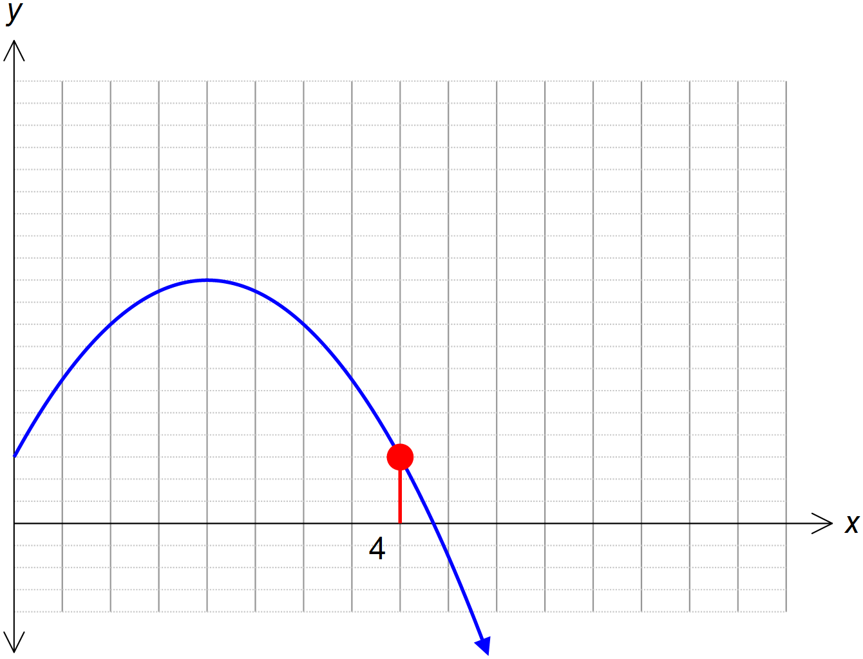






The dog has to jump 1.5m to catch the ball.

